**Network Analysis of Multi-state Relationships During the Chunqiu Period Based on the Zuozhuan**

Yuerong Hu, School of Information Sciences at University of Illinois at Urbana-Champaign   
Ian Reid, School of Information Sciences at University of Illinois at Urbana-Champaign

KEYWORDS

Network analysis, distant reading, Chinese literature

1 INTRODUCTION

Zuozhuan is an ancient Chinese narrative history classic that is widely regarded as a commentary on the ancient Chinese chronicle Chunqiu from 722 to 468 BC. It covers history events happened over 250 years among 145 states with around 2400 characters involved in it. Zuozhuan has an extremely complex narrative structure with massive amount of historical records about inter-states relationships embedded in its text. Generations of scholars and researchers have devoted considerable amount of time and energy to interpret and organize the contents of Zuozhuan.

Previous research on Zuozhuan are mainly qualitative and subjective interpretations of the literal text. Few of them involve quantitative methods and objective evidence. However, through our reading, we found there are a few network analysis projects based on Zuozhuan, which have used characters as nodes and their social connections as edges. These network analysis projects shed lights on our own research proposal. We decided to rebuild the complex inter-state network with data extracted out of the text of Zuozhuan to analyze the historical relationships of all the states during the Chunqiu period.

2 LITERATURE REVIEW

2.1 Limitations of Previous Research

Previous works on the inter-state relationship mainly focus on relations among 2, 3, or 5 states due to the limitations of scholar’s research methods. Most of the research adopt qualitative methods which involve closing reading and bibliographic studies. None of them looks into this problem from the perspective of most of the states. Conclusions are mostly subjective interpretations based on the scholars’ personal knowledge and understanding of the original text of Zuozhuan.

2.2 Insights into New Research

Through the reading of previous research, we have realized that there are abundant semi-structured information and data available in Zuozhuan. Zuozhuan is an ideal object for historical network analysis. However, the relationships among states are very complicated and heterogeneous. For example, it can be very challenging to identify and classify the type of some events depending on the researcher’s point of view. Besides, some original records in Zuozhuan are vague and incomplete. Although there are more than 100 states mentioned in Zuozhuan, a large number of them only appeared no more than 3 times. Considering all these facts, we believe that undirected network is more practical for network analysis of Zuozhuan instead of directed network due to the limitations of the information available.

2.3 Novelty of New Research

This research aims at taking advantages of network analysis, a data driven approach, to study the multi-state relationship based on the semi-structured data extracted from Zuozhuan. We intend to focus on the overall relationships among all the states instead of arguing for an interpretation based on a few states. We will produce visualization model, quantitative evidence and statistical results to support our findings. We hope that with this data-driven method, we could avoid the pitfalls of previous qualitative studies base on subjective interpretations. Furthermore, we want to compare our findings with previous conclusions drawn out of qualitative studies to verify their reliability.

3 METHOD AND WORKFLOW

3.1 Overall Workflow

This research starts from a literature review of previous literal studies on Zuozhuan and network analysis on diplomatic/international relationships. Then we work on data description design (structure, scaling, and characteristics), data collection, data transformation and data visualization in sequence. Finally, we analyze the data based on the graphic and statistic results we are able to produce. We use the software Gephi for our network analysis.

3.2 Data Description and Data Collection

The first step of our project is extracting “data” from then original text of Zuozhuan. This part of work was more time-consuming that what we had expected and it took us about 2 weeks to get the data extraction work done. We first drafted a state node codebook composed of the node ID, original Chinese state name and their English transitions. This is supposed to provide nodes and labels for the following work.

Table 1. Part of the State Code Book

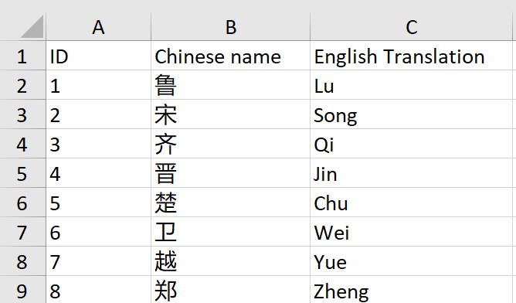

We used the two tables in Lanxi Deng’s doctoral thesis appendix to generate structure records of war and alliance data sets in Zuozhuan. We had to (1) delete redundant information such as page information and Lu calendar information (2) identify the type of events and delete the events that do not fall into neither category of war nor alliance (3) identify the states involved in each event, which asks us to constantly go back to the

original text of Zuozhuan for reference).

Table 2. Original Textual Information Extracted from Deng’s Doctoral Thesis

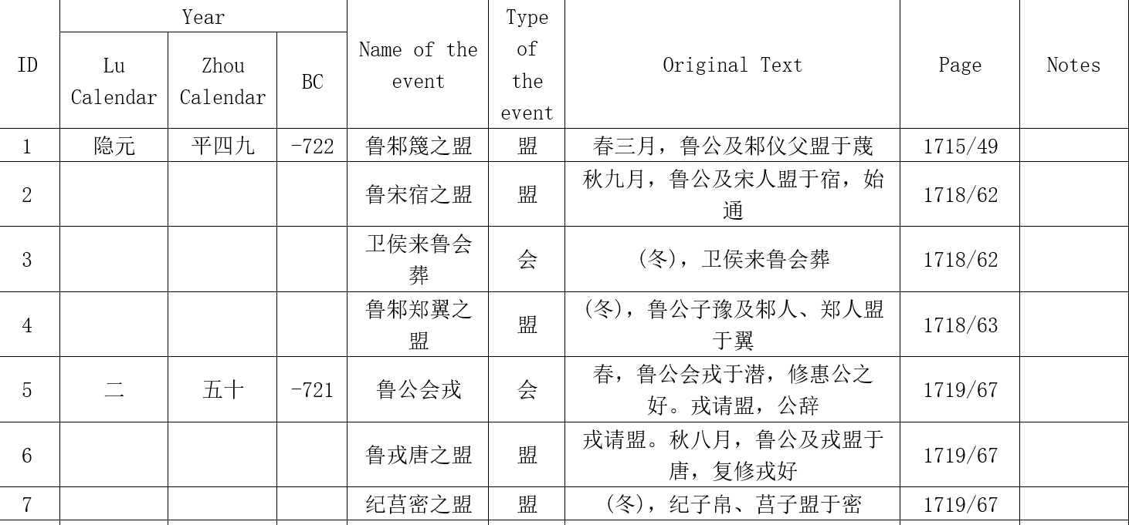

Table 3. Modified Information

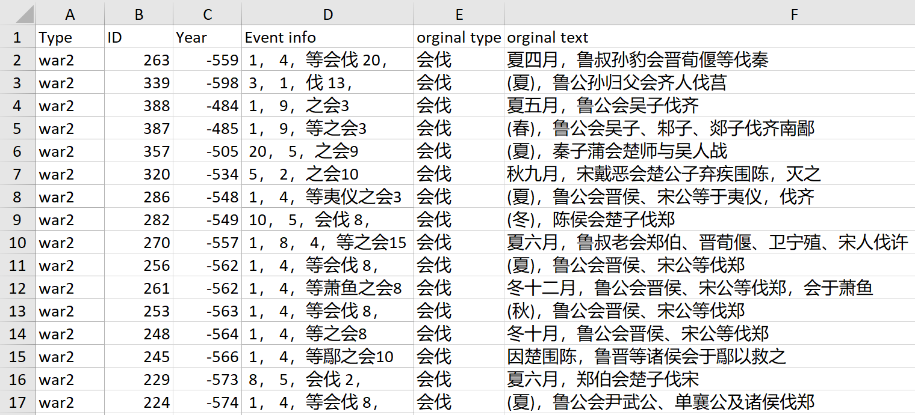

3.3  Data Transformation

Next, we further cleaned the data and transformed all the data into records of nodes and edges. Considering the complexity of network, we decided to first conduct network analysis for each general type of events: war or alliance. However, we would combine them together in one network later. For all the records of alliance and war, we thought undirected edges were more appropriate for our network analysis. One record was transformed into one or more edges (node, node) depending on the number of nodes (states) involved in it. In this way, we were able to create matrix for all the records.

Table 4. Reforming the Data with Matrix

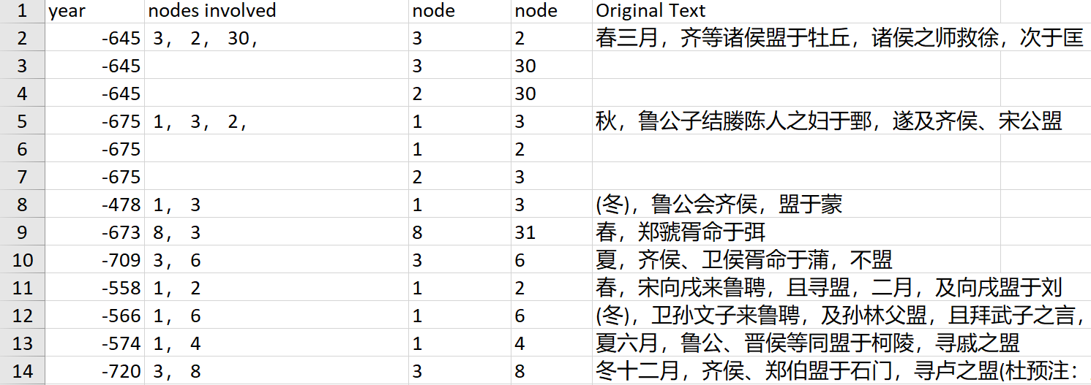

3.4  Data Visualization

We chose to use Gephi for our project because we believed Gephi has many good visualization layouts that can help us understand the relationships among the nodes. In order to visualize the data in Gephi, we only kept the data of year and the nodes involved in both types of records. After loading each dataset into Gephi, we set the layout to Fruchterman Reingold, weighed the edges to see how well connected each node was to others, and ran the statistics functions to find out more information about the network.

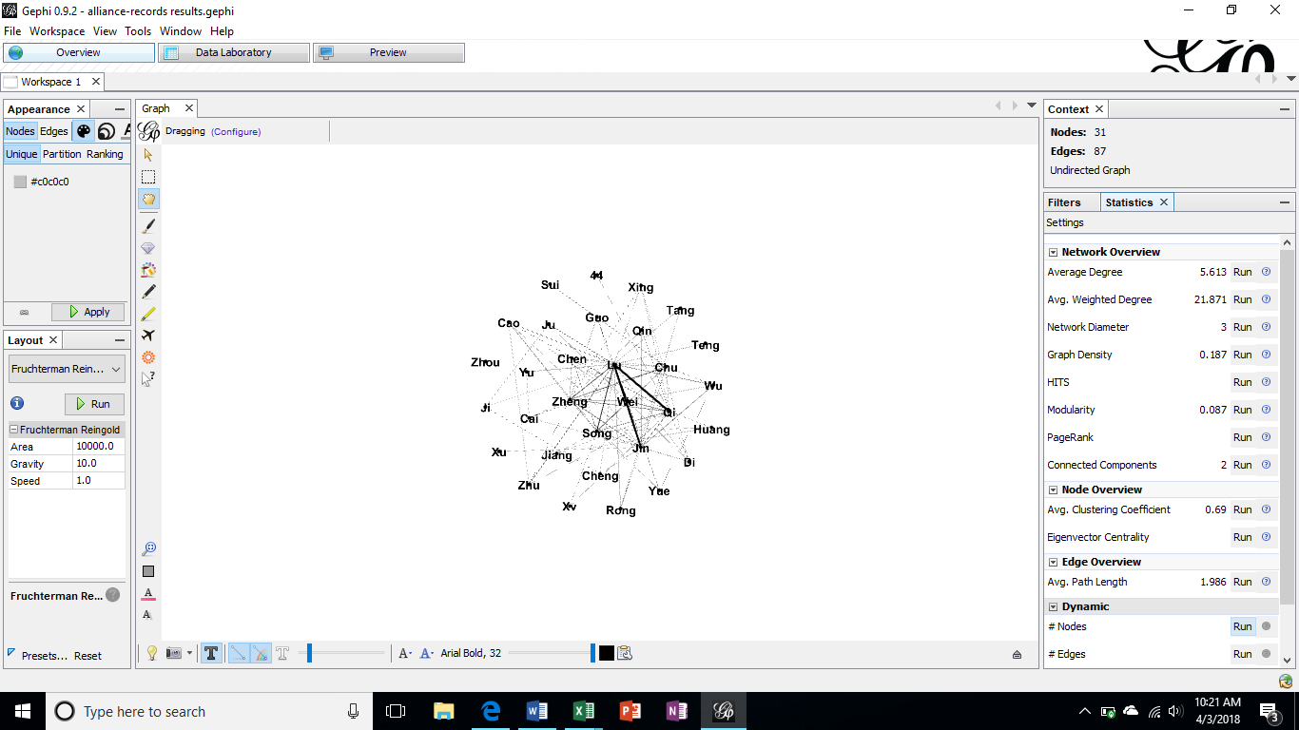

Fig. 1. Loading Alliance data into Gephi.

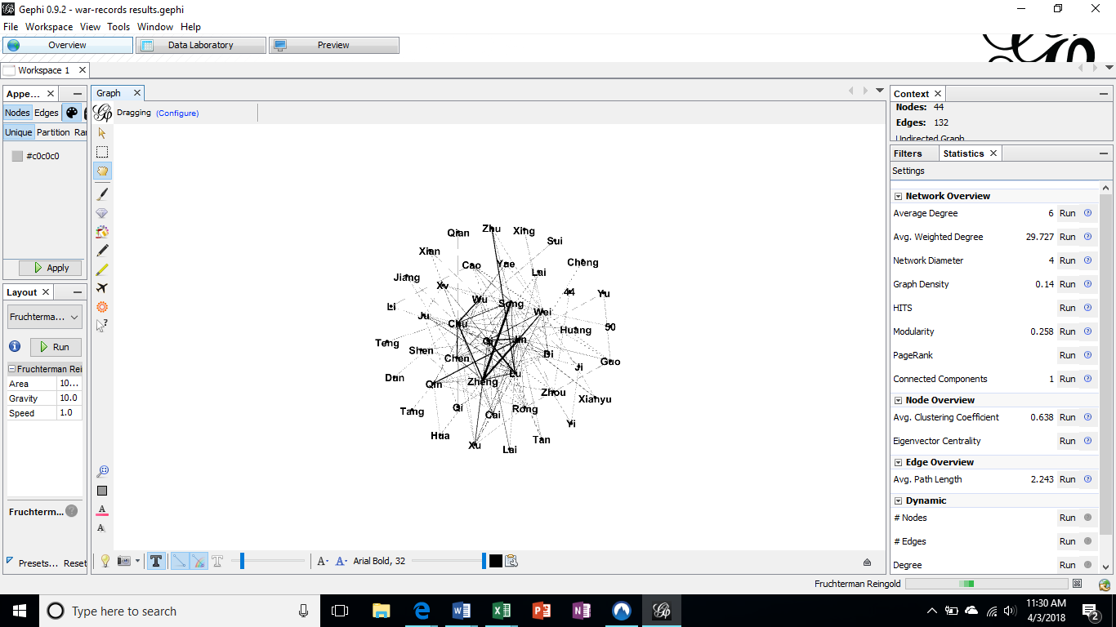

Fig. 2. Loading War data into Gephi

4 OUTCOME AND FINDINGS

4.1  War Network

The undirected network of war has 42 nodes with 130 edges. Average degree is 6.19 and average weighted degree is 31.048. Network diameter is 4 and graph density is 0.14.

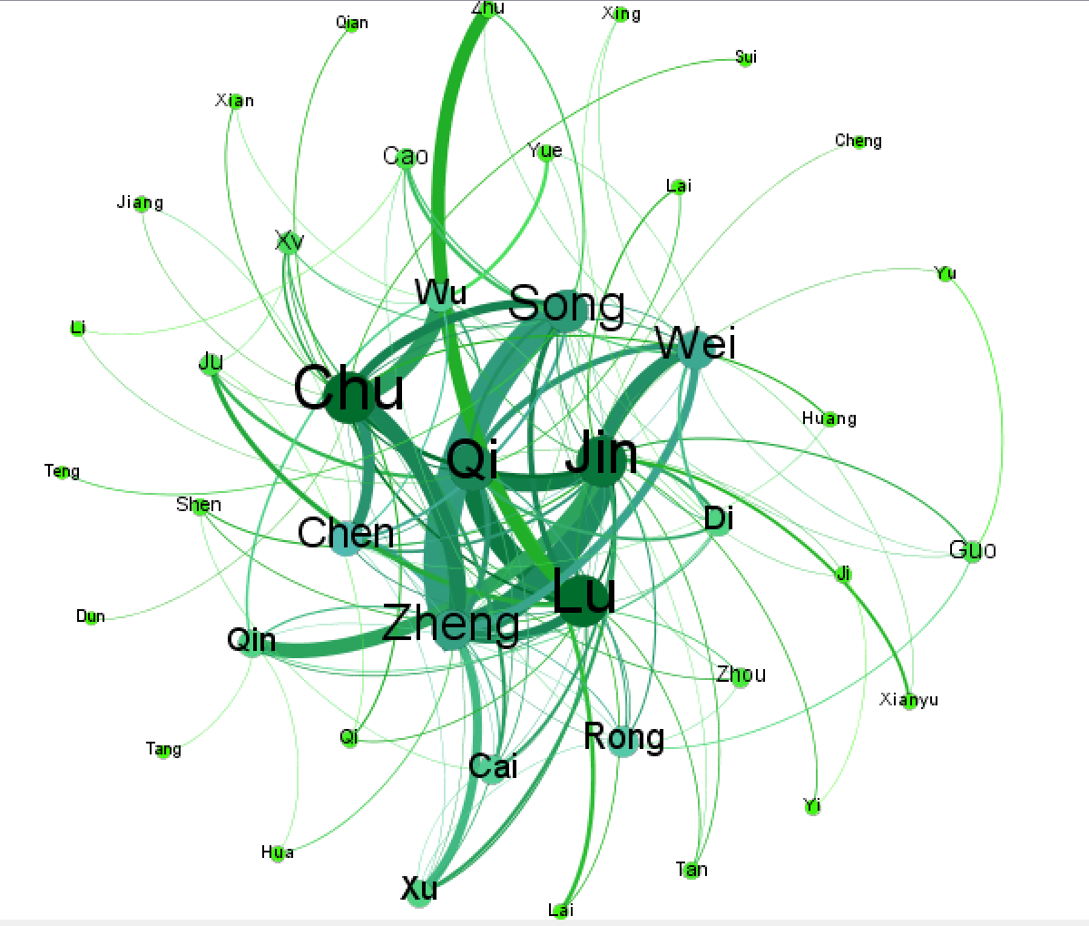

Fig. 3. War Network

According to our observation, all states participate in war with at least one other state, and a high network clustering coefficient (.649) means that most of the states are connected too much of the network. Many nodes on the fringes of the Fruchterman Reingold layout of the network have only one or two connections with the Xu (8), Guo (4) and Zhu (3) being notable exceptions. The average path length is a little over two (exactly 2.116) meaning that most states should have some familiarity with the other states even if through second-degree connections.

The low graph density means that while there are many connections in the war network, there are many more potential links that have not been explored. For example, many of the states on the outer rim of the Fruchterman Reingold layout of the network do not have any connections to each other one exception are the Yu and Guo states. The strongest ties in terms of war are between the Zheng and Song states and the Zheng and Jin states, this is based on width of edges between them. Of the most connected states (in green) the Chu has 21 connections, the Qi has 18, the Jin 22, and the Lu has 21.The middle most connected states (blue colored nodes) are the Xu (8), Rong (9), Cai (7), Zheng (15), Chen (12), Qin (8), Wu (7), Song (16), and Wei (14).

4.2  Alliance Network

The undirected network of war has 30 nodes with 86 edges. Average degree is 5.733 and average weighted degree is 22.533. Network diameter is 3 and graph density is 0.198.

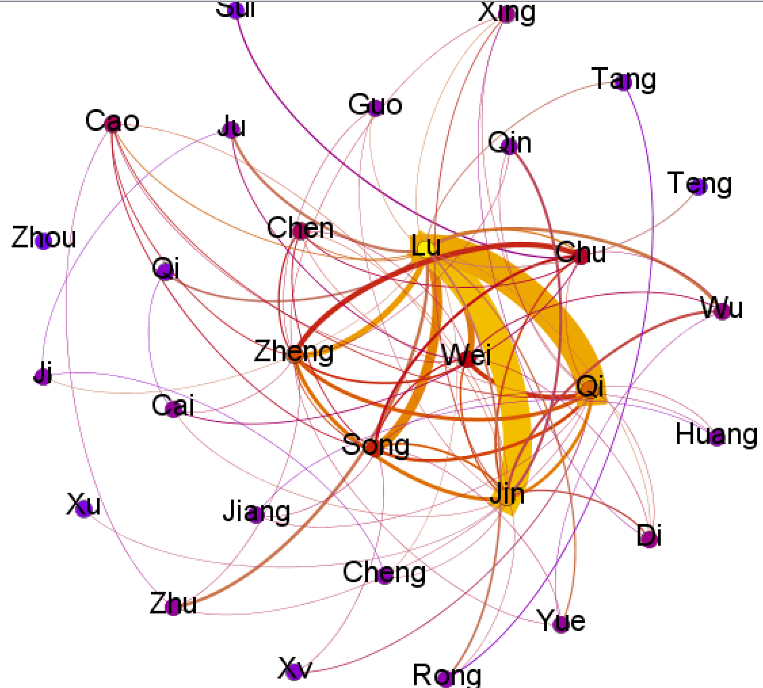

Fig. 4. Alliance Network

According to our observation, unlike many nodes many nodes on the fringes of the Fruchterman Reingold layout of the war network which have only one or two connections with the Xu (8), Guo (4) and Zhu (3) being notable exceptions, many nodes in a similar position in the alliance network Fruchterman Reingold layout have more than one node. The Zhu and Yue have 4, The Cao has 7, and The Xing, Wu, and Di each have 5. All states (except the Zhou) participate in alliances with at least one other state, and a high network-clustering coefficient (.692) means that most of the states are connected to much of the network.

The low graph density means that while there are many connections in the war network, there are many more potential links that have not been built. For example, none of the states on the outer rim of the Fruchterman Reingold layout of the network does not have any connections to each other and the Zhou is not connected to anyone. The strongest ties in terms of war are between the Lu and Jin states and the Lu and Qi states; this is based on width of edges between them. Of the most connected states (in yellow) the Lu has 21 connections, the Qi has 15, and the Jin has 17.The middle most connected states (red colored nodes) are the Zheng (14), Chu (8), Song (12), Wei (9).

Between the networks, three of the most connected nodes for alliances are also some of the most connected nodes for war. The strongest ties for war (Zheng and Song, Zheng and Jin) did not lead the Zheng or the Song to have particularly strong connections in terms of alliances. The Jin, however, does become a strongly linked state. With a higher Clustering Coefficient, the states seem to be much more united by alliances than war.

5 CONCLUSIONS

Between the networks, three of the most connected nodes for alliances are also some of the most connected nodes for war. The strongest ties for war (Zheng and Song, Zheng and Jin) did not lead the Zheng or the Song to have particularly strong connections in terms of alliances. The Jin, however, does become a strongly linked state. With a higher Clustering Coefficient, the states seem to be much more united by alliances than war. Comparing to previous literature, our findings confirm the arguments existed in previous literature. First, the edges of higher weight and nodes of bigger size (higher degree) are consistent with the powerful states and influential inter-states relationships.

6 LIMITATIONS AND FUTURE WORK

There remain 3 problems for further investigation :( 1) How to correctly and fully interpret all the data and statistic results we have gotten; (2) How to connect our data to interpretations of previous literature; (3)How to realize dynamic network analysis. We may also experiment on community detection and ego network analysis based on our dataset of the multi-state network.

REFERENCES

|  |  |
| --- | --- |
| [1] | Chao, Xu., & Xiaohe, Chen. (2014). Social Network Analysis of Spring and Autumn Period based on Zuo Zhuan. Journal of School of Chinese Language and Culture Nanjing Normal University, 14(1), 179-184. |
| [2] | Chen, J. W., Borovsky, Z., Kawano, Y., & Chen, R. (2014). The Shishuo xinyu as Data Visualization. Early Medieval China, 2014(20), 23-59. |
| [3] | Erlin, M., & Tatlock, L. (Eds.). (2014). Distant Readings: Topologies of German Culture in the Long Nineteenth Century. New York: Camden House. |
| [4] | Franco, Moretti. (2011). Network Theory, Plot Analysis. Stanford Literary Lab Pamphlets. Retrieved from https://litlab.stanford.edu/LiteraryLabPamphlet2.pdf, Retrieved on May 1, 2018. |
| [5] | Li, B., Wang, L., Wen, Y., Chen, X., & Gu, Y. (2017, October). Discover social relations and activities from ancient Chinese history book Zuo Zhuan. In Behavioral, Economic, Socio-cultural Computing (BESC), 2017 International Conference on (pp. 1-5). IEEE. |
| [6] | Xiaohe, Chen., Minxuan, Feng., & Runhua, Xu. (2013). Processing Pre-Qin Literature. Beijing: World Publication. |
| [7] | Yong, D. (2007). Wang-Ba: Justice and Order —From Wars in Spring-Autumn Period To Universal Justice. Retrieved from Wuhan University Digital Dissertations. |

Journal Name:ACM Trans. Graph.

Volume:4

Issue:2

Year:2017

Month:October

Article Seq:XXXX

DOI:124564

Copyright Year:2017

Copyright Statement:rightsretained

ISSN:0730-0301

Price:$15.00